Cheetah

Use-Case Specification: Add Lecturer

Version 1.0

Revision History

|  |  |  |  |
| --- | --- | --- | --- |
| **Date** | **Version** | **Description** | **Author** |
| 21/11/2016 | 1.0 | Initial Version | Damian Pistorius, Lior Olszewski, Sara Olszewski |
|  |  |  |  |
|  |  |  |  |
|  |  |  |  |

Table of Contents

1. Use-Case Name 4

1.1 Brief Description 4

2. Flow of Events 4

2.1 Basic Flow 4

3. Special Requirements 6

3.1 Functionality in the Browser 6

4. Preconditions 6

4.1 Log-In 6

5. Postconditions 6

5.1 Submit 6

6. Extension Points 6

Use-Case Specification: Add Lecturer

# Use-Case Name

## Brief Description

This use case allows the student to create his professor if he isn’t existing yet.

# Flow of Events

## Basic Flow

**Activity Diagram:**



**Mock-Up:**

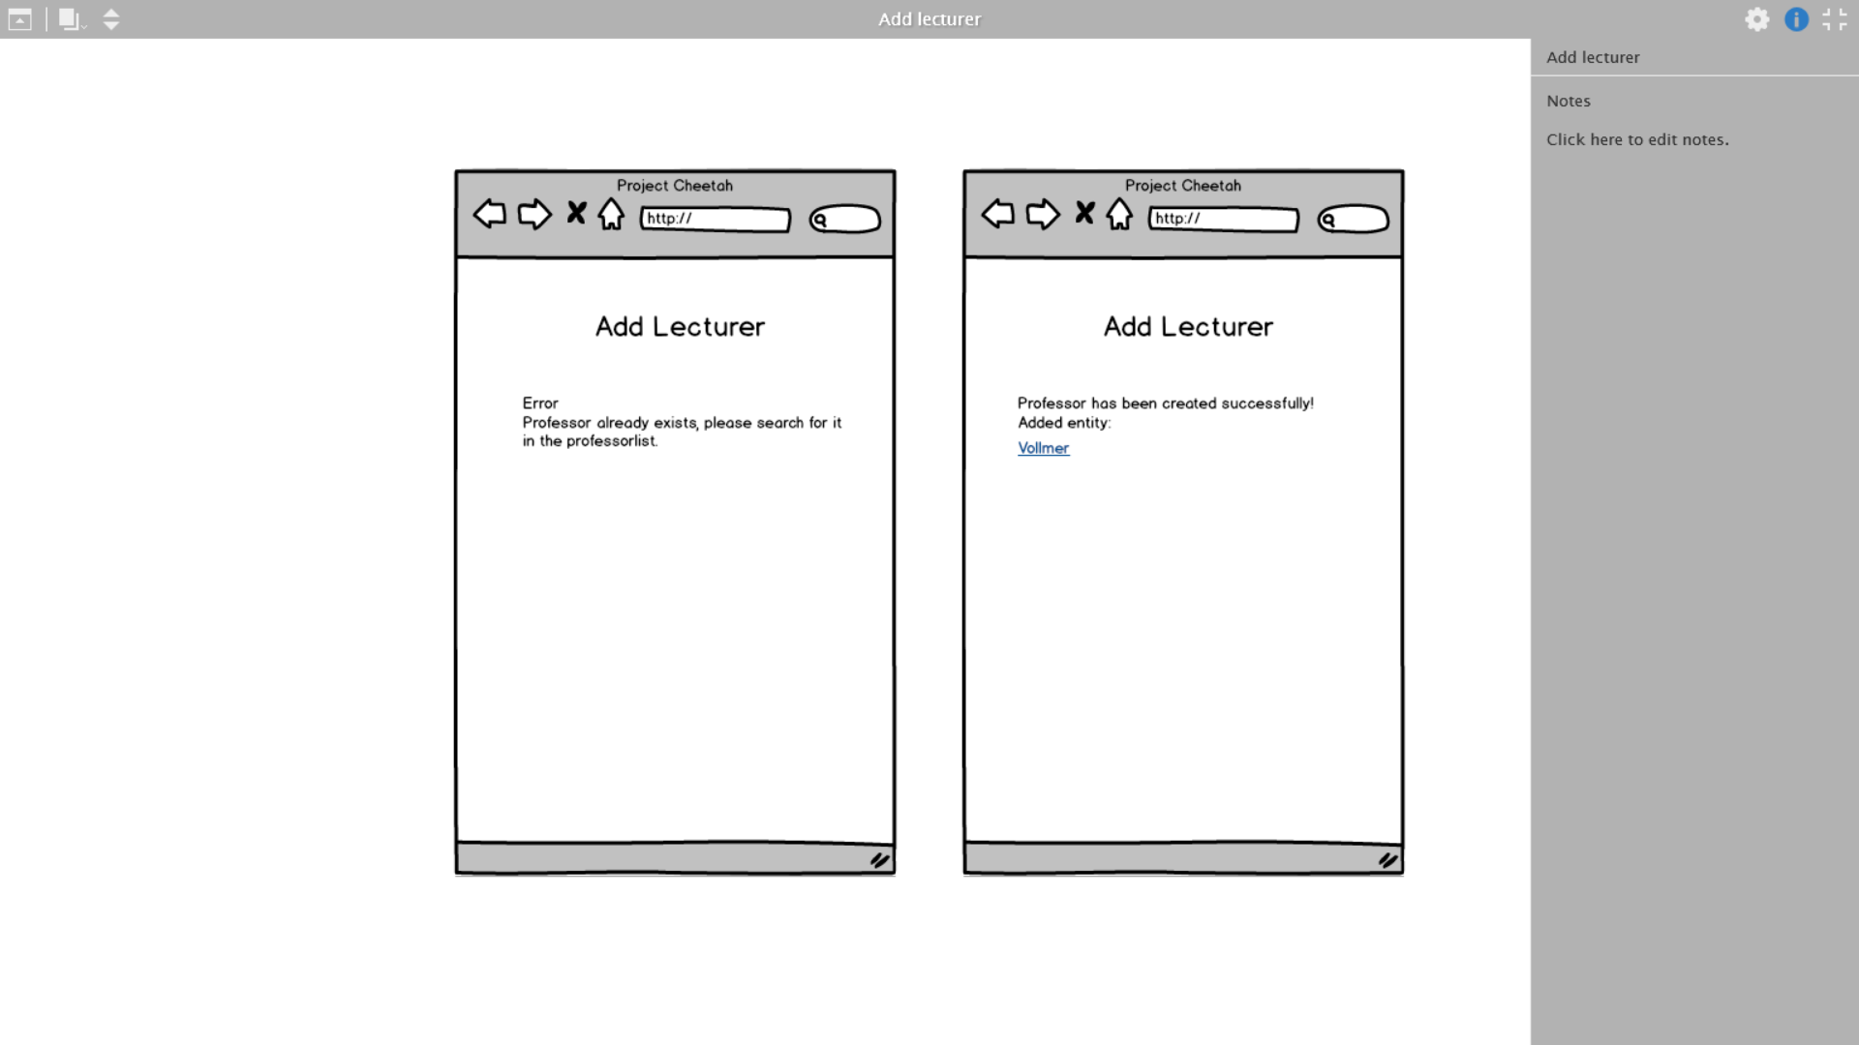

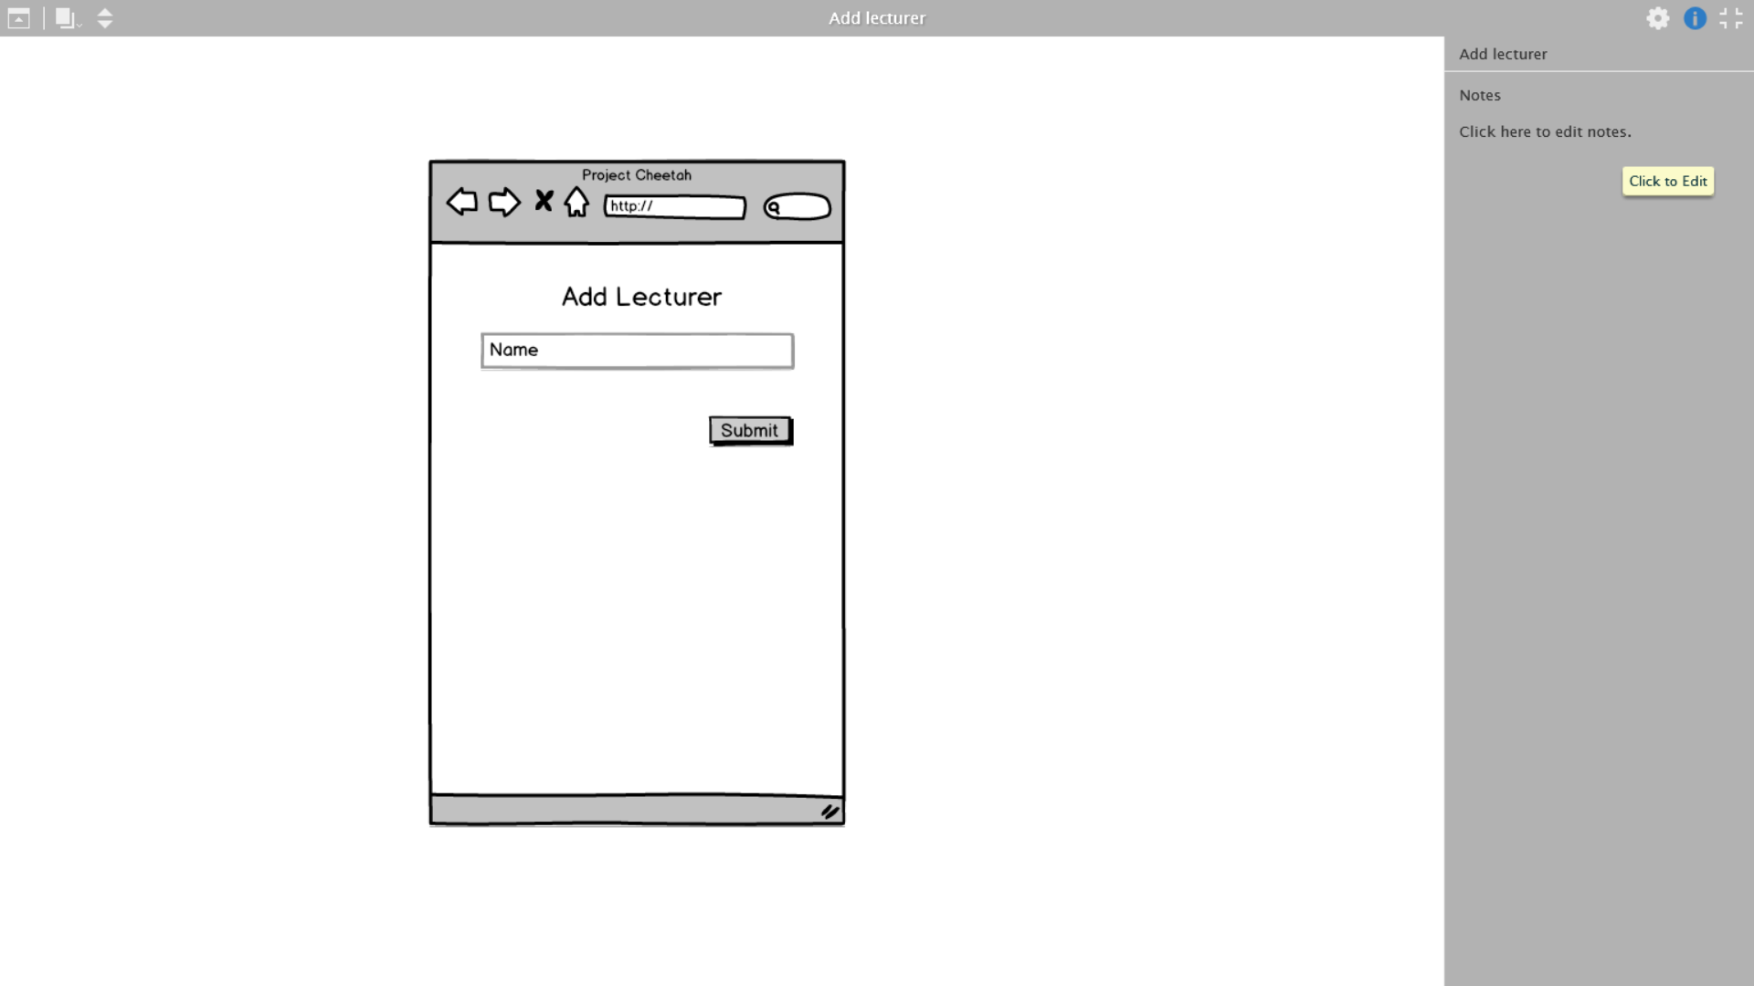

If exists



If not exists

# Special Requirements

## Functionality in the Browser

Since it will be a web application, it should fit every browser. It should have a responsive design.

# Preconditions

## Log-In

The student has to be registered, logged in and chosen a school and course.

# Postconditions

## Submit

The student has to press the submit button so the database can create and add the new professor.

# Extension Points

N/A